**Design Document: Decision Table Builder**

**1. Project Overview** the Decision Table Builder is a simple web-based tool designed to help users create structured decision tables. These tables consist of conditions, actions, and rules, allowing users to logically represent decision-making scenarios. This tool guides the user through inputting conditions and actions, then dynamically generates all possible rule combinations.

**2. Design Goals**

* Provide a simple and intuitive interface
* Allow users to enter conditions and actions with ease
* Automatically generate a decision table with all possible rule combinations
* Display results in a clean, readable format

**3. User Interface Design** The tool consists of three main areas:

* **Input Section**: Text fields for entering conditions and actions
* **Controls**: Buttons to add/remove inputs and to generate the table
* **Output Section**: A dynamic table displaying all rules

Example:

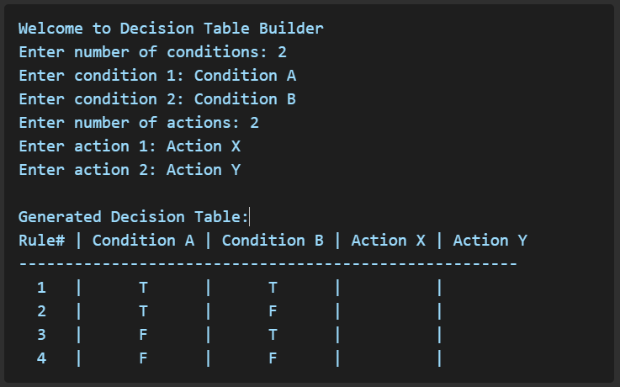

**4. System Components**

* **Condition Manager**: Handles creation, deletion, and storage of condition inputs
* **Action Manager**: Same as above, for actions
* **Table Generator**: Uses binary logic to generate all combinations of conditions and map them to actions
* **UI Renderer**: Updates the output table based on current inputs

**5. Tools and Technologies**

* C++ for application logic
* Standard Template Library (STL) for data structures and processing
* Local desktop execution (not web-based)

**6. Assumptions and Constraints**

* The tool is single-user, single-session
* All processing is done client-side (no backend)
* Supports up to ~10 conditions and ~10 actions before performance degrades